Types Of Storms
A storm is basically a natural disaster which is caused by any change in the atmosphere, whether it is a change in pressure, temperature or the water level. It usually involves heavy rains strong winds which can cause a lot of destruction.
Storms are formed when a system of low pressure air is surrounded by a system of high pressure air.
These two air systems, at different pressures create very high speed winds and form storm clouds that can cause heavy rains.
There are many different types of storm below given are few types of storms:

Thunderstorm
Thunderstorm is a type of storm where there is a severe lightening in the sky. The sky turns black and it is accompanied by heavy or moderate rainfall.

Hail Storm
The hail storm is a severe kind storm in which heavy and strong winds blow accompanied by hail stones and ice pellets.
These ice pellets can vary form 0.2 -0.5 cm in diameter.
These hailstones that fly along with the fast moving wind can be dangerous and cause a lot of destruction.
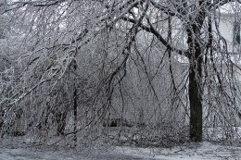
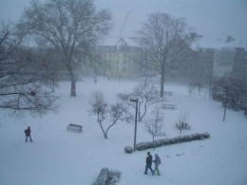
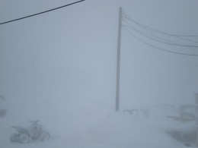
Blizzard conditions

Ice Storm
Ice storm is similar to the hail storm in a way as both involve strong winds, ice and both occur in the winter season but in the ice storm the wind does not carry ice pellets and hailstones but due to the lowering of the temperature below the freezing point causes the rain in the air to freeze and the water freezes as soon as it lands down.

Snow Storm
A snow storm is a storm when there is a heavy snowfall and strong winds.

Blizzard Storm
Blizzard storm is a worse form a snow storm where the snow fall is accompanied strong winds blow at the speed of 35 miles per hour for hours.

Famous Avalanches
- Types Of Avalanches And Famous Avalanches
You are on vacation and find a prefect spot for skiing down hill, you start up perfectly and by the time your in the middle of your down hill trip suddenly a huge mass of ice and snow breaks away beneath you.
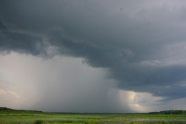
Rain clouds

Rainstorm
A storm in which there is a heavy rain fall accompanied by strong winds and lightening.
One may confuse rainstorm with thunder storm but they differ in a way that in thunder storm there is a much concentration of lightening which hits hard on the ground and the rain may not be as heavy as in rainstorm.
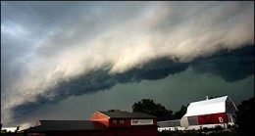
A straight-line windstorm
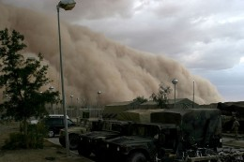
A Sandstorm

Wind Storm
A wind storm is a storm where strong and powerful winds blow.
This storm may or may not include rain and can be very dangerous as the strong wind can do a lot of damage because it may carry dust and stones with it.
If the windstorm is very violent and is accompanied by hailstones and rain then it is called tempest but if it is a moderate short lived windstorm then it is known as squall.

Dust Storm
Dust storm is a type of wind storm in which the strong winds carry dust and sand particles with them.

Sand Storm
A sand storm is different than a dust storm although they may sound similar. A sand storm is a very dangerous kind of wind storm that occurs in a desert or in sandy areas.
The winds blow from the deserts carrying a large amount of sand with it which can cause a lot of destruction. The winds blowing can rise up to 50 feet in height and engulf the entire land covering it with sand.
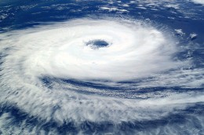
A cyclone

Cyclones
A cyclone is an extremely dangerous type of storm in which winds rotating either clockwise or anticlockwise hit the land.
Cyclones are extremely dangerous and are very violent and destructive.
A cyclone twits its way harshly along the land damaging everything and taking along with it whatever comes its way.
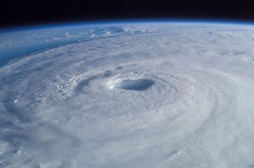
Hurricane Isabel (2003)

Famous Hurricane Disasters
- Famous Hurricanes
Hurricane, also known as tropical cyclone, is one of the most destructive and dangerous natural disaster. This storm is combination of numerous storms which have low pressure at centre.

Famous Tornado Disasters
- Famous Tornadoes
The Tornado is defined as violently rotating dark funnel like cloud containing column of air. It develops below a heavy cumulonimbus cloud collection and extends towards the earth.
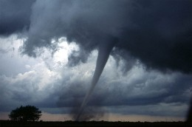
A tornado

Hurricane
A hurricane is a very severe type of cyclone. It originates near the equator travels towards the north and since it moves toward the north it rotates in a counter clockwise direction.
Hurricane is accompanied with heavy rains and is a very dangerous storm. It can cause massive destruction and is probably one of the deadliest natural disasters in general.
In 2005 the hurricane Katrina that hit the United States is believed to be one of the most destructive hurricanes of all time.

Tornado
A tornado is another type of cyclone in which funnel shaped fast whirling air hits the ground.
The cyclone during a tornado is accompanied very heavy rains and lightening. Basically the tornado is the funnel shaped whirling of air which causes a huge destruction.
Tornadoes are very violent and usually rotate clockwise in most of the cases. Tornadoes can also be a whirling water sprout if they occur over the sea.

