Forces and Motion
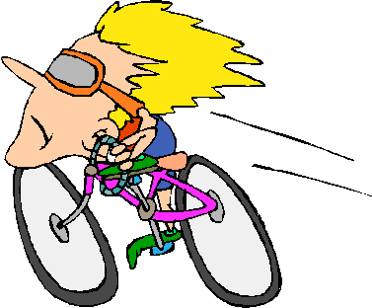

By: ______________________________
Motion

Definition: __________________________________________________________________________________________________________________________________________

Caption: ________________________________________________________________________________________________________________________________________________________________________________________
Position

Definition: __________________________________________________________________________________________________________________________________________

Caption: ________________________________________________________________________________________________________________________________________________________________________________________
Frame of Reference

Definition: __________________________________________________________________________________________________________________________________________

Caption: ________________________________________________________________________________________________________________________________________________________________________________________
Relative Motion

Definition: __________________________________________________________________________________________________________________________________________

Caption: ________________________________________________________________________________________________________________________________________________________________________________________
Speed

Definition: __________________________________________________________________________________________________________________________________________

Caption: ________________________________________________________________________________________________________________________________________________________________________________________
Force

Definition: __________________________________________________________________________________________________________________________________________

Caption: ________________________________________________________________________________________________________________________________________________________________________________________
Acceleration

Definition: __________________________________________________________________________________________________________________________________________

Caption: ________________________________________________________________________________________________________________________________________________________________________________________
Newton

Definition: __________________________________________________________________________________________________________________________________________

Caption: ________________________________________________________________________________________________________________________________________________________________________________________
Gravity

Definition: __________________________________________________________________________________________________________________________________________

Caption: ________________________________________________________________________________________________________________________________________________________________________________________
Weight

Definition: __________________________________________________________________________________________________________________________________________

Caption: ________________________________________________________________________________________________________________________________________________________________________________________
Friction

Definition: __________________________________________________________________________________________________________________________________________

Caption: ________________________________________________________________________________________________________________________________________________________________________________________

